CHAPTER 2
SOFTWARE LIFE-CYCLE MODELS
Figure 2.1. Waterfall model representation of the Winburg mini case study.

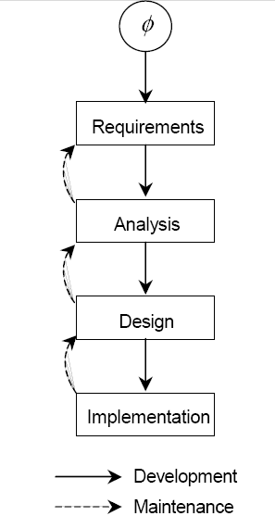

2.1: Figure 2.1 shows the waterfall model representation of the Winburg mini case study.
(This figure is identical to Figure 2.3 of Object-Oriented and Classical Software Engineering, Seventh Edition.) The problem is that the figure does not show the sequence of events, that is, which artifact follows which. It is therefore far less effective than themevolution-tree model.

2.2: Episode 2 falls away, and Figure 2.2 shows the resulting evolution tree when single precision numbers are used at the beginning.
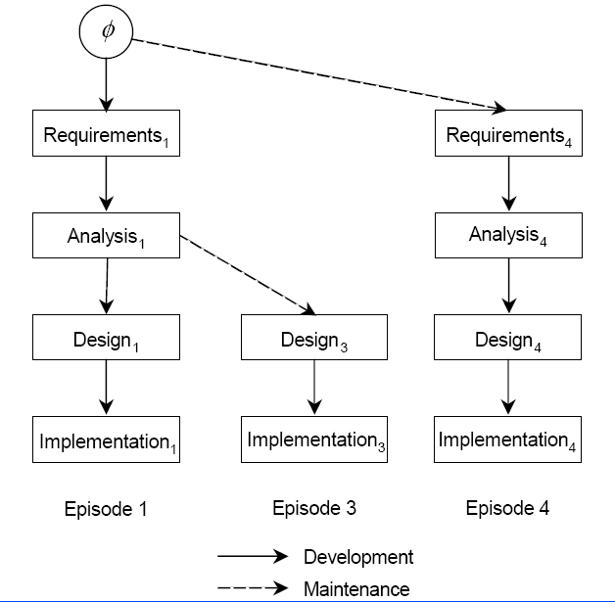

2.3: Because of Miller’s Law we cannot develop a software product in a single step, and therefore we need to use stepwise refinement.

2.4: Incrementation.

2.5: A workflow is a set of activities.
An artifact is a constituent component of a software product.
A workflow creates or modifies one or more artifacts.
A baseline is a set of artifacts.

2.6: The iterative-and-incremental life-cycle model is equivalent to a sequence of waterfall life-cycle models.

2.7: Code-and-fix. There is nothing to be gained by using a more sophisticated model.

2.8: Experience and skills of the development team; computer literacy of the client; extent to which the client seems to appreciate his or her real needs.

2.9: The product may not be what the client really needs, so construct a rapid prototype. The design may not permit future development as the corporation grows or changes the way it does business, so ensure that the design is as open-ended as is reasonable. There may be cost and or time overruns, so estimate carefully (see Chapter 9). The users may not be comfortable with the product, so a rapid prototype of the user interface is needed; also, involve the purchasing clerks, factory supervisors, sales clerks, and so on, in the development loop. A competitor may produce off-the-shelf software before the product has been delivered — there is no ethical way to resolve this risk. A critical member of the development team may leave, so keep management of the development organization abreast of major decisions being made, thereby making it easier to integrate a replacement into the team. The development team may not be properly managed, so ensure that managers are competent and well-trained.

2.10: The key requirements here are achieve portability, maintainability, and generality. Excellent documentation is essential for this, so the waterfall model appears to be a strong candidate. However, the waterfall model is a theoretical model, so the iterative and incremental life-cycle model is probably the life-cycle model of choice here.

2.11: Infrastructure software that is likely to be extremely widely used by a broad variety of users. For example, an operating system or web browser.

2.12: Software to be used in only one organization. For example, a software product to control a machine of a unique type.

2.13: A small product, particularly one in which the requirements are vague.

2.14: A medium- or large-scale product.

2.15: A large-scale, in-house project. For example, a flight-control system that is developed in house.

2.16: A small product, or any form of contract software. For example, a database conversion program developed under contract.

